LAB MANUAL
TAHA MUZAMMIL RASOOL
456279
LAB TASKS
TASK 1
#include<iostream>
using namespace std;
float SumOfArray(float arr[],int total)
{
int sum=0;
for(int ri=0;ri<total;ri++)
{
sum+=arr[ri];
}
return sum;
}
float AverageOfArray(float sum,int total)
{
return sum/total;
}
int main()
{
int total=5;
float arr[total]={21,45,23,8,6};
float sum=SumOfArray(arr,total);

float Average=AverageOfArray(sum,total);

cout<<"The average of an array : "<<Average;
}
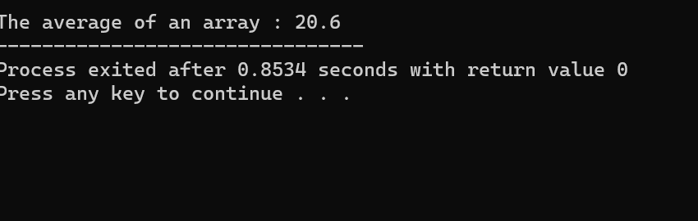

TASK 2
#include <iostream>
using namespace std;
void bubbleSort(int arr[], int n) {
for (int i = 0; i < n - 1; ++i) {
for (int j = 0; j < n - i - 1; ++j) {
if (arr[j] > arr[j + 1]) {
int temp = arr[j];
arr[j] = arr[j + 1];
arr[j + 1] = temp;
}
}
}
}

int main() {
const int size = 5;
int myArray[size] = {6, 1, 8, 1, 6};

cout << "Original Array: ";
for (int i = 0; i < size; ++i) {
cout<< myArray[i] << " ";
}

bubbleSort(myArray, size);

cout << "\nSorted Array: ";
for (int i = 0; i < size; ++i) {
cout<< myArray[i] << " ";
}
}
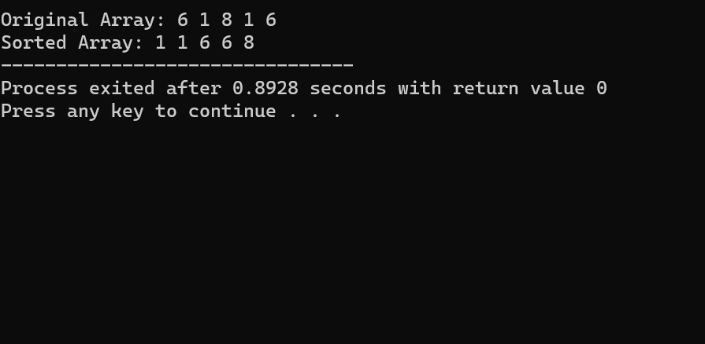

TASK 3
#include <bits/stdc++.h>
using namespace std;
void selectionSort(int arr[], int n) {
for (int i = 0; i < n - 1; i++) {
int indexMin = i;
for (int j = i + 1; j < n; j++) {
if (arr[j] < arr[indexMin]) {
indexMin = j;
}
}
swap(arr[indexMin], arr[i]);
}

cout << "Array after sorting:" << endl;

for (int i = 0; i <= n - 1; i++) {
cout << arr[i] << " ";
}
}

int main() {

int array[] = {12, 3, 4, 16, 11, 5, 9};
int size = 7;
selectionSort(array, size);
}
